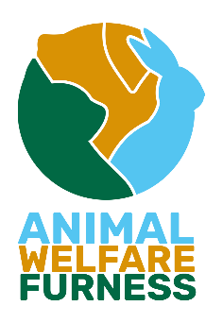
ANIMALWELFARE (FURNESS)

Registered Charity No. 1189973
VAT No: GB 817 4254 30
Registered Address
210 Dalton Road, Barrow in Furness, Cumbria, LA14 1PN.
Tel: (01229) 811122

Adoption Application

Name of cat/kitten you would wish to apply for:

To start the application, we need to know what you’re looking for in a cat/ kitten and learn about your home and lifestyle.
Your details:

Name:
Age:
Contact Number:
Address:

Your home:

Do you own your home or rent? (if rented we need proof of permission from landlord)

Do you have any other cats in the household (if yes are they neutered & vaccinated? how old?)

Do you have any other pets? (if yes, what pets?)

Do you have any children at home? (If yes, how old are the children?
(We do not rehome to families with children under the age of 5)

Do you have a preference on gender, age, and colour?

Do you live near any busy roads or trainlines?

Your lifestyle:

Are you looking for a house cat (indoor only)?

Are you wanting a cat that can go outside?

How many cats would you like to rehome?

Do you have any upcoming holidays planned?

Do you have any experience with cats?

Is this your first cat?

Do you have any health conditions that prevent you from meeting the cats basic needs?

We also require a virtual house check which is just photos of your living area, kitchen area and any outside space.
You must be at least 18 years of age to adopt from Animal Welfare Furness.
There is a non-refundable minimum adoption donation of £100 for cats & £150 kittens. This covers vet checks, microchipping, neutering, vaccinations, FIV/FELV test and flea & worm treatment while in our care.

